These pages are designed to show you how to use software packages; various software updates may have taken place so some pages will not apply to versions other than those listed here. In some cases data files may be required.

Title or Task: | Making a Dreamweaver Site    
Description: | Create a web site

Files Required
Suitable for Classes: | AIT • Multimedia • Cert II IT • Cert II Bus
Area: | Technology & Enterprise
Teacher: | Mr Peter Faulks
Timeline | 1 Lesson

Date Due:
Task Brief: | Create a folder (site) and first page
Outcomes: | Ability to use web authoring tool like Dreamweaver

Items highlighted in yellow are tasks for you to complete
Items in Blue italics are help tips

PHOTO ALBUM in a Table
- Open your Dreamweaver site.
- Create a folder for your photo album (e.g. album) and insert at least 5 images same size
- Open any page within the site
- Insert a table
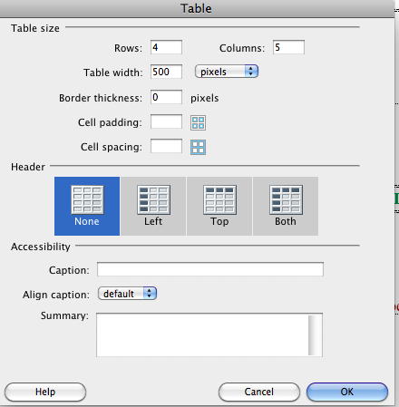

Align Center
Drag first image to cell 1 and number 1
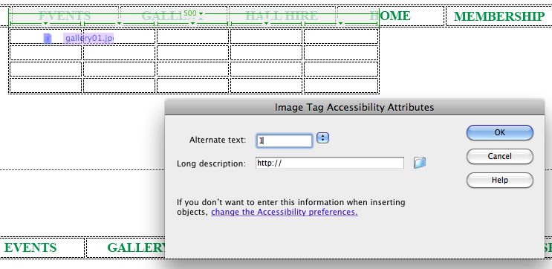
You can change the size in the properties window
For each row type a label then make height 40 Center and Top
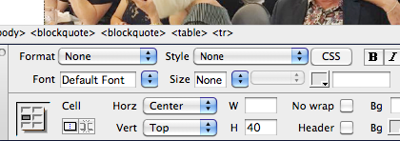

Link each image to the images in your site and make the border 0
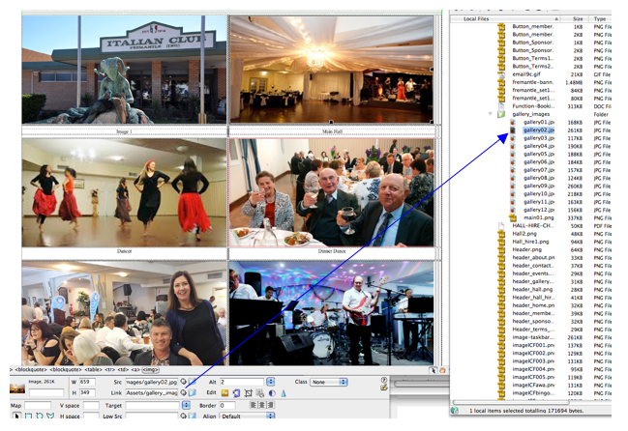
On each page Type Previous Gallery Next then save and duplicate the page 6 times
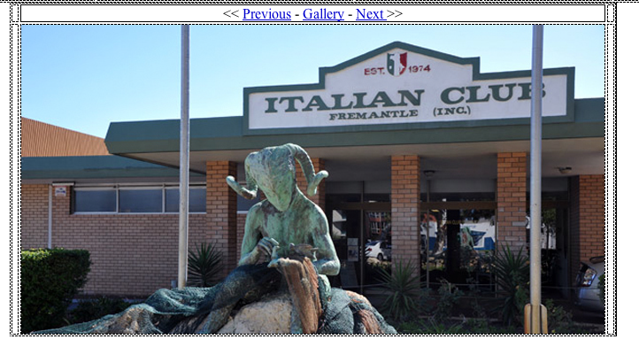
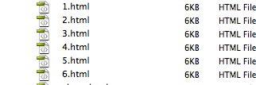
- Choose Commands/Create Web Photo Album from the toolbar
  - Give the album a title (this will show in the thumbnail page only)
  - You can enter subheading info if you like (this will show in the pages with the enlarged pictures)
  - Choose the Source images folder by using the folder icon to browse to the relevant folder (this will be the folder where you have stored all the images)
  - Choose the destination folder (from our example 'album')
  - Choose the thumbnail size from the drop-down menu
  - You can enter the number of columns you would like to display the thumbnails
  - The rest can be left as is or changed according to your requirements for optimization
  - Click on OK
  - You will see Fireworks creating the thumbnails for all the pictures
  - Once this is done, you will receive a message saying that the photo album has been created and you can view the album.
- The album will now be in it's simple unformatted state. You will have a folder called album under which there will be 3 folders as follows:
  - thumbnails - contains the thumbnails
  - images - contains the images in its original form
  - pages - contains the pages in which the larger images are inserted along with the navigation to navigate between pictures and go back to home
  - index.htm page which will have all the thumbnails with links to the larger images
- You can now go to the index page and apply your template (if you have one) to format the page and also use CSS Styles to format the text. The gallery now will look like its part of the site. You can do this for all the pages in the pages folder (under the gallery folder).
You can view completed examples of web photo albums at www.sunbeam4kids.com. These are pages we have developed with the Dreamweaver Web Photo Album. Once the album was created we applied the template and formatted the text with CSS Styles. Click on the images thumbnails to navigate between the pictures.
Take a look at some of our ready made Flash Photo Gallery Website Templates here

Features of the Entheos Free Simple Flash & XML Photo Gallery :
- Add unlimited number of images
- Next and Previous buttons to navigate - The next and previous buttons get disabled when you reach the last or first image.
- Images are loaded externally from a photos folder
- Neat fade-in and fade-out image transition effect
- Add images and captions easily in an XML file which can be easily edited in Notepad
Steps to use this simple Flash Photo Gallery
- Download the zip file and extract the files. You will have a folder called Photo_Gallery1 which will have photos.xml, photogallery.html, photogallery.swf and a photos folder.
- Make sure your images are in the following dimensions and in .jpg format :
Width : 360 px
Height : 300px
- Copy all the images to the folder called photos.
- Open photos.xml and edit the file names and headings. E.g
<image filename="oimg1.jpg" heading="Ballet" />
oimg1.jpg and Ballet should be changed to your image filename and image heading
- To delete images simply delete the line pertaining to that image in the xml file and delete that image from the photos folder.
- To add additional images, simply add a new line of code similar as above and edit the file name and the heading.
Terms of Use
- The Entheos Flash Photo Galleries may be used in any kinds of personal and/or commercial projects.
- The Entheos Flash Photo Galleries may not be redistributed or resold to other companies or third parties.
More Free Flash & XML Photo Galleries
- Dynamic Flash & XML Photo Album with Categories
- Dynamic Flash & XML Slideshow Photo Gallery
More Flash & XML Photo Galleries

Part 2: Creating a Slideshow in Dreamweaver CS3
Dreamweaver CS 3 includes direct support to add a simple slideshow to your web page, however, this feature has been removed from Dreamweaver CS4 and CS5, replaced by the Widget of free or purchase. But if you are still using Dreamweaver CS3, feel lucky to follow easy steps to create a slideshow in Dreamweaver.
- 1. Move cursor to the place you want to insert a slideshow and select Insert > Media > Image Viewer.
- 2. Save the element to the folder of your page (recommended). In the Save Flash Element dialog box, enter a name and click Save.
- 3. The Flash element placeholder will be inserted in your page and the Tag inspector opens to the right.
- 4. Select the Flash element placeholder and open Tag Inspector (or Windows -> Tag Inspector)
- 5. Click the blank area beside the imageURLs parameter, and then click the " Edit Array Values" icon (it's at the end of the line).
- 6. In the pop-up Edit imageURLs Array dialog box, click the Plus (+) button to add images, click the Minus (-) button to remove element placeholder.
- 7. Click OK to close the dialog box. Likewise, you can use the Tag inspector to set other parameters.
- 8. With the Image Viewer selected, click the Play button to preview the Image Viewer. Use the buttons to control the viewer.





